Automation System Design
Smart Home Lighting System with Motion & Light Sensors

1. Introduction
Home automation refers to the use of electronic systems to control household functions with minimal human intervention. A Smart Home Lighting System is one of the most common and practical automation applications: it turns lights on automatically when a room is occupied and dark, and switches them off automatically when the room is empty or already well lit. This report presents the design of such a system, including its objective, hardware components, control logic, and the accompanying flowchart (submitted as a separate design file).

2. Objective
The objective of this system is to automatically control room lighting based on two conditions: (1) whether a person is present in the room, and (2) whether the ambient light level is low enough to require artificial lighting. This reduces unnecessary power consumption, adds convenience, and removes the need for manual switching.

3. System Components
The system combines two sensing elements, a controller, and an actuator, summarised below:
Component | Function
PIR Motion Sensor | Detects human presence/movement in the room
LDR (Light Dependent Resistor) | Measures ambient light level to sense daylight vs darkness
Microcontroller (e.g. Arduino/ESP32) | Reads sensor inputs and runs the control logic
Relay Module | Switches the mains-powered light ON/OFF based on controller output
Light Source (LED bulb) | The actuator/output device that is controlled
Timer (software) | Keeps the light on for a set duration after last motion, then triggers auto-off

4. Working Principle
The system continuously monitors its two sensors in a loop. The step-by-step logic, illustrated in the attached flowchart (smart_lighting_flowchart.svg / .png), is as follows:
- The system starts and continuously reads data from the PIR motion sensor and the LDR light sensor.
- Decision 1 — Motion Detected? If no motion is sensed, the system takes no action and keeps monitoring. If motion is detected, it proceeds to the next check.
- Decision 2 — Is the Ambient Light Low (Dark)? If the room already has sufficient daylight, the light is kept OFF and the system returns to monitoring. If the room is dark, the system proceeds to switch the light on.
- Activation — The microcontroller signals the relay module to turn ON the light, and a delay timer (e.g. 60 seconds) starts.
- Decision 3 — Motion Detected Before Timeout? If further motion is detected before the timer expires, the timer resets and the light stays ON, extending occupancy time.
- Auto Shut-off — If no further motion is detected before the timer expires, the relay is deactivated and the light turns OFF automatically.
- The system then loops back to continuous sensor monitoring, repeating the cycle indefinitely.

5. Flowchart Reference
The complete visual flowchart is provided as a separate design file (smart_lighting_flowchart.svg, with a rendered smart_lighting_flowchart.png). A reduced copy is included below for reference.
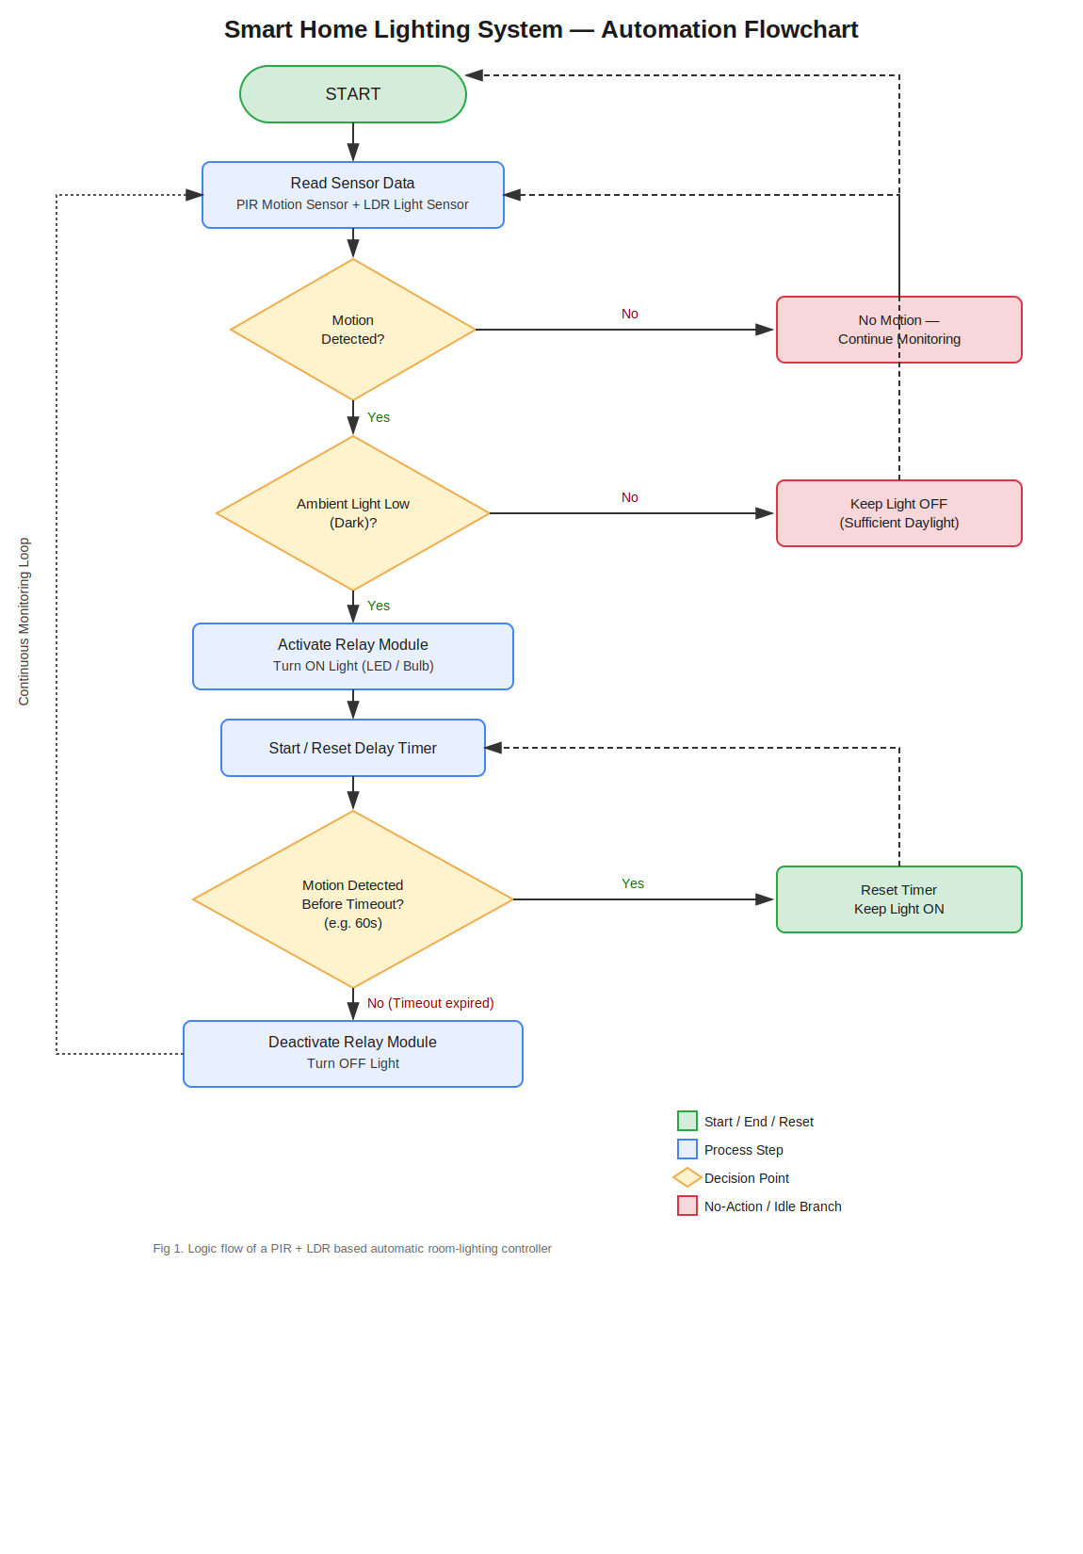
Fig 1. Flowchart of the smart home lighting automation logic

6. Advantages
- Energy saving — lights are never left on in an empty room or during daylight.
- Convenience — no manual switches needed; fully hands-free operation.
- Extendable — the same PIR + LDR + relay logic can be replicated per room and networked (e.g. via Wi-Fi/IoT) for whole-house control.
- Low cost — built from inexpensive, widely available sensor and relay modules.

7. Applications
- Residential rooms, corridors, and staircases
- Office spaces and washrooms
- Parking areas and building entrances
- Street lighting (LDR-only variant, without PIR)

8. Conclusion
The proposed smart home lighting system demonstrates a simple but effective automation loop built around two sensors, a microcontroller, and a relay-driven actuator. By combining occupancy detection (PIR) with ambient light sensing (LDR) and a timeout-based control loop, the system achieves reliable, energy-efficient, and fully automatic lighting control suitable for real-world deployment.

